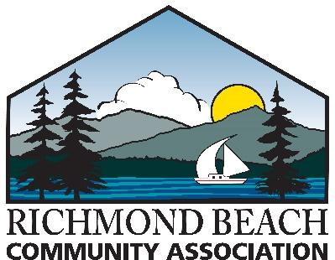

P. O. Box 60186 – Richmond Beach, WA 98160-0186
www.richmondbeachwa.org

Richmond Beach Community Association – Scholarship Application Form
Please download and complete this on-line application form and attach your essay.
Email your completed application form and essay to: scholarship@richmondbeachwa.org
Applications are due by Friday, May 20, 2022
Scholarship recipients will be notified beginning Wednesday, June 1, 2022
Name: _____________________________________________________
Address: _____________________________________________________
Telephone Number: _____________________________________________________
Email Address: _____________________________________________________
High School: _____________________________________________________
Graduation Date: _____________________________________________________
Name of institution you plan to attend: ______________________________________________
Certification and Release Authorization: I certify this information is true, complete, and accurate. I declare this submission to be my original work. I also authorize release of information to confirm and/or verify this application. If I am awarded a scholarship, RBCA may use my name for publicity purposes.
Student’s Signature: __________________________________________ Date: ____________
Parent’s Signature (if under 18 years old): ____________________________________________

The Richmond Beach Community Association is a 501(c)(4) social welfare organization. Our mission is to promote the well-being of the Richmond Beach community.

